In student Management system project defines an HTTP server using Gorilla Mux for routing. It initializes routes for CRUD operations on user data. The server listens on port 8080, creating endpoints to manage user data through POST, GET, PUT, and DELETE requests. Upon receiving a request, the router directs it to the respective handler function for processing based on the HTTP method and endpoint specified. A connection to a MongoDB database hosted on MongoDB Atlas using the package. It sets up a connection to the database named "test" and the collection named "Users." Upon execution of the function, it establishes a connection to the MongoDB server, verifies the connection, and sets the collection variable to perform CRUD operations on the "Users" collection within the "test" database. If successful, it prints "Connected to MongoDB" Otherwise, it logs any encountered errors during the connection setup process.

*CreateUser creates a new person in the MongoDB collection*

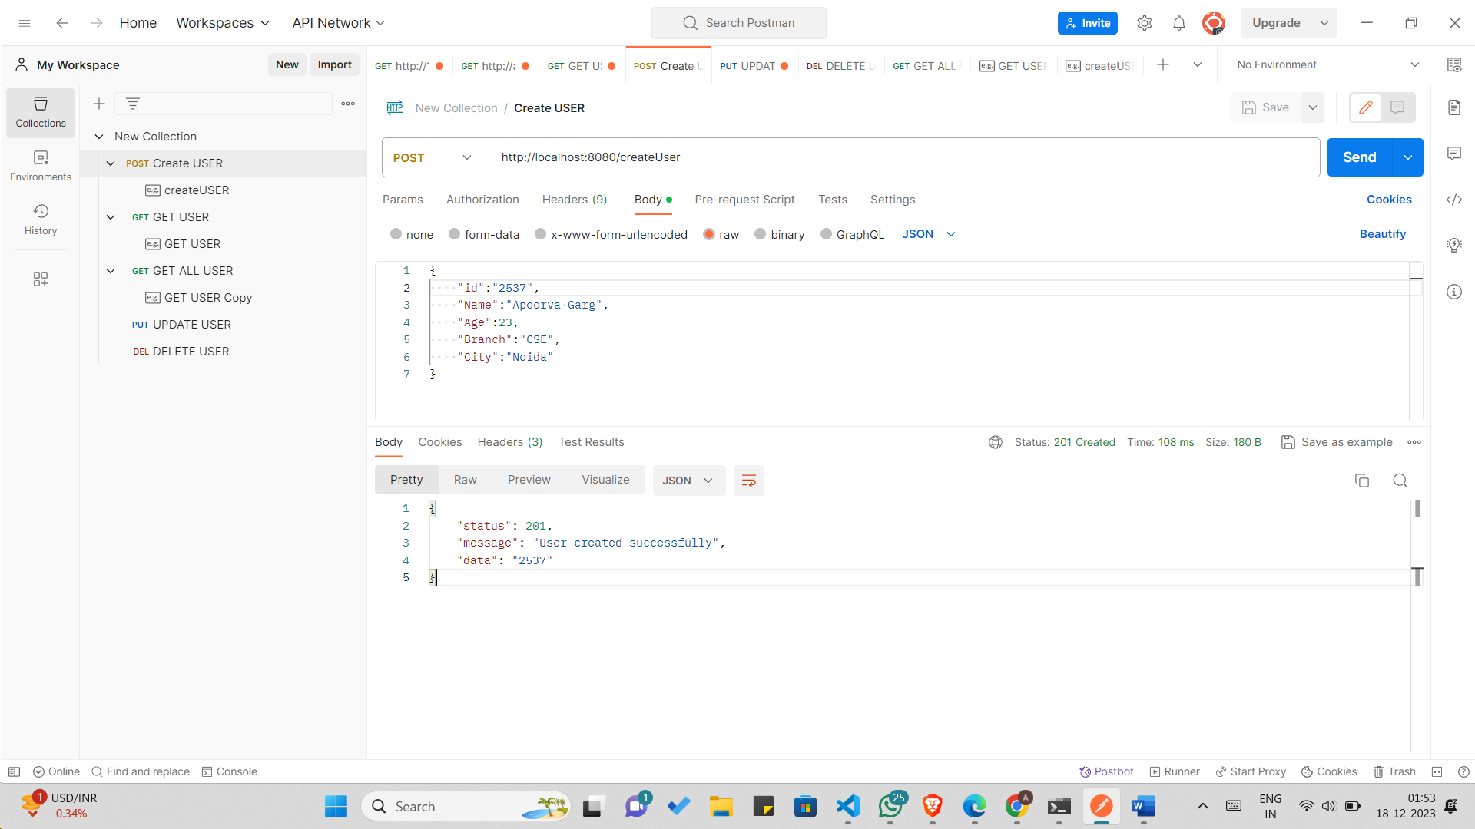

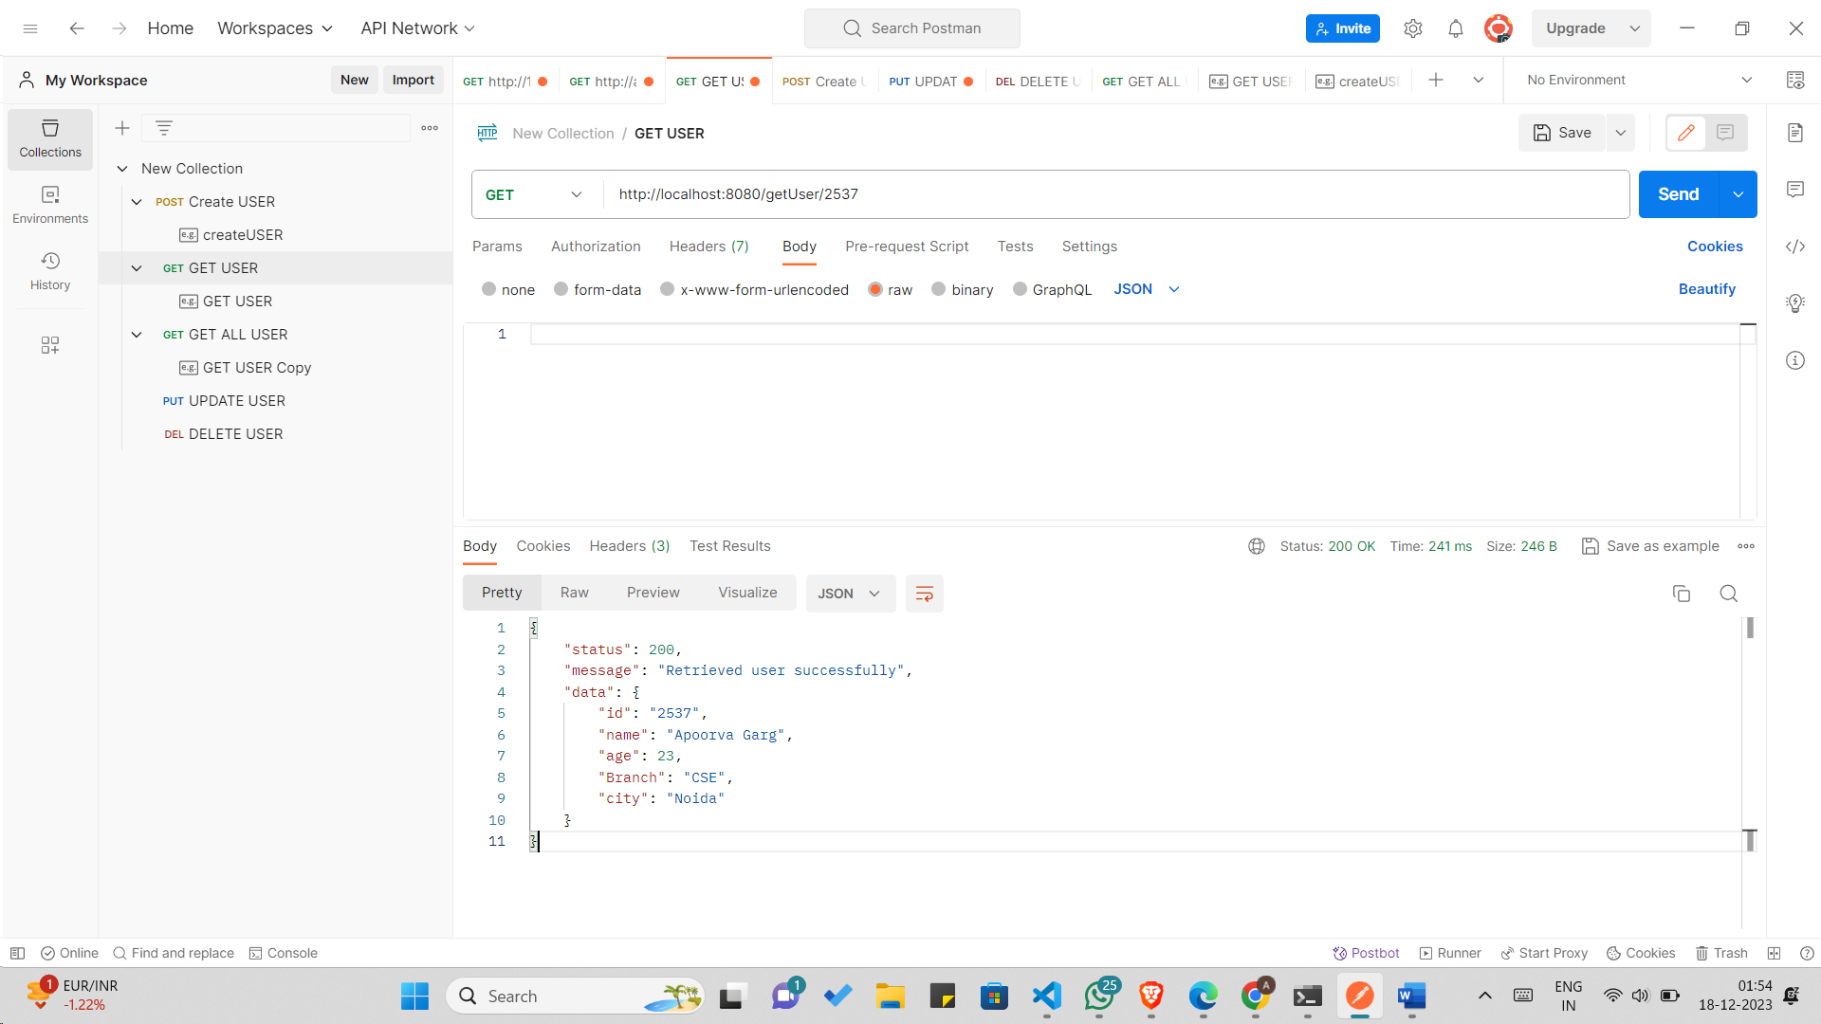

*// GetUser returns a specific person from the MongoDB collection by ID*

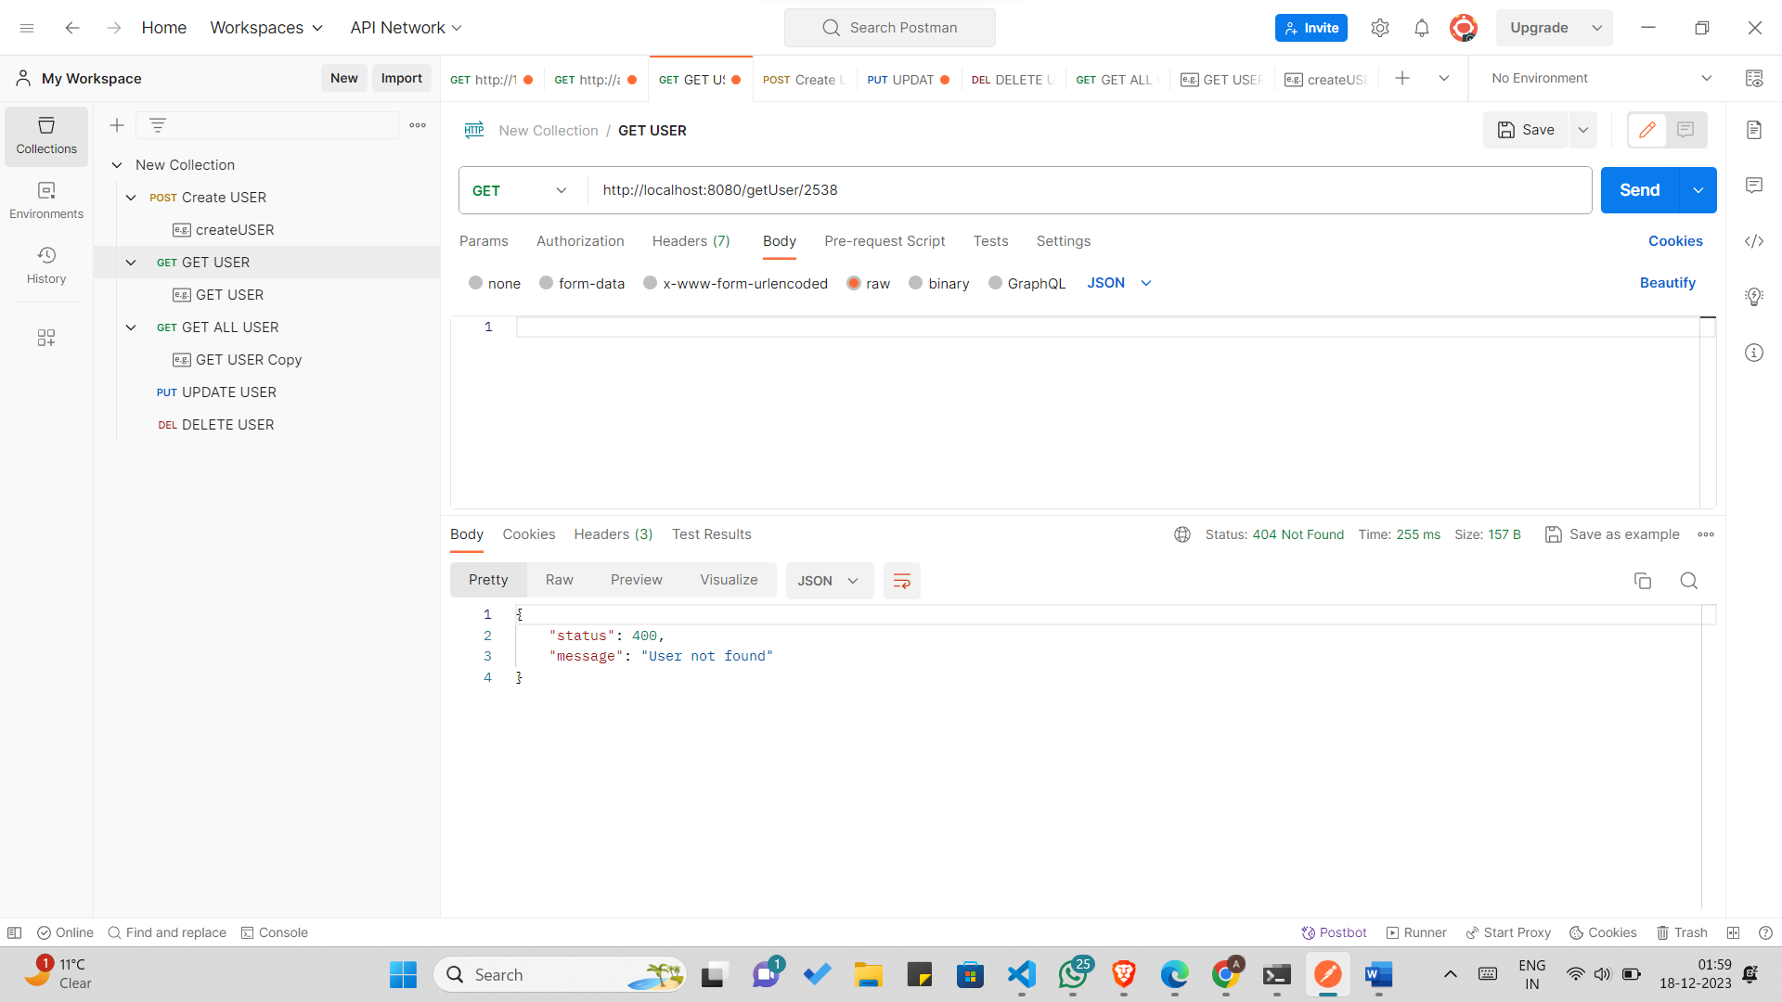

*GetUser returns all people from the MongoDB collection*

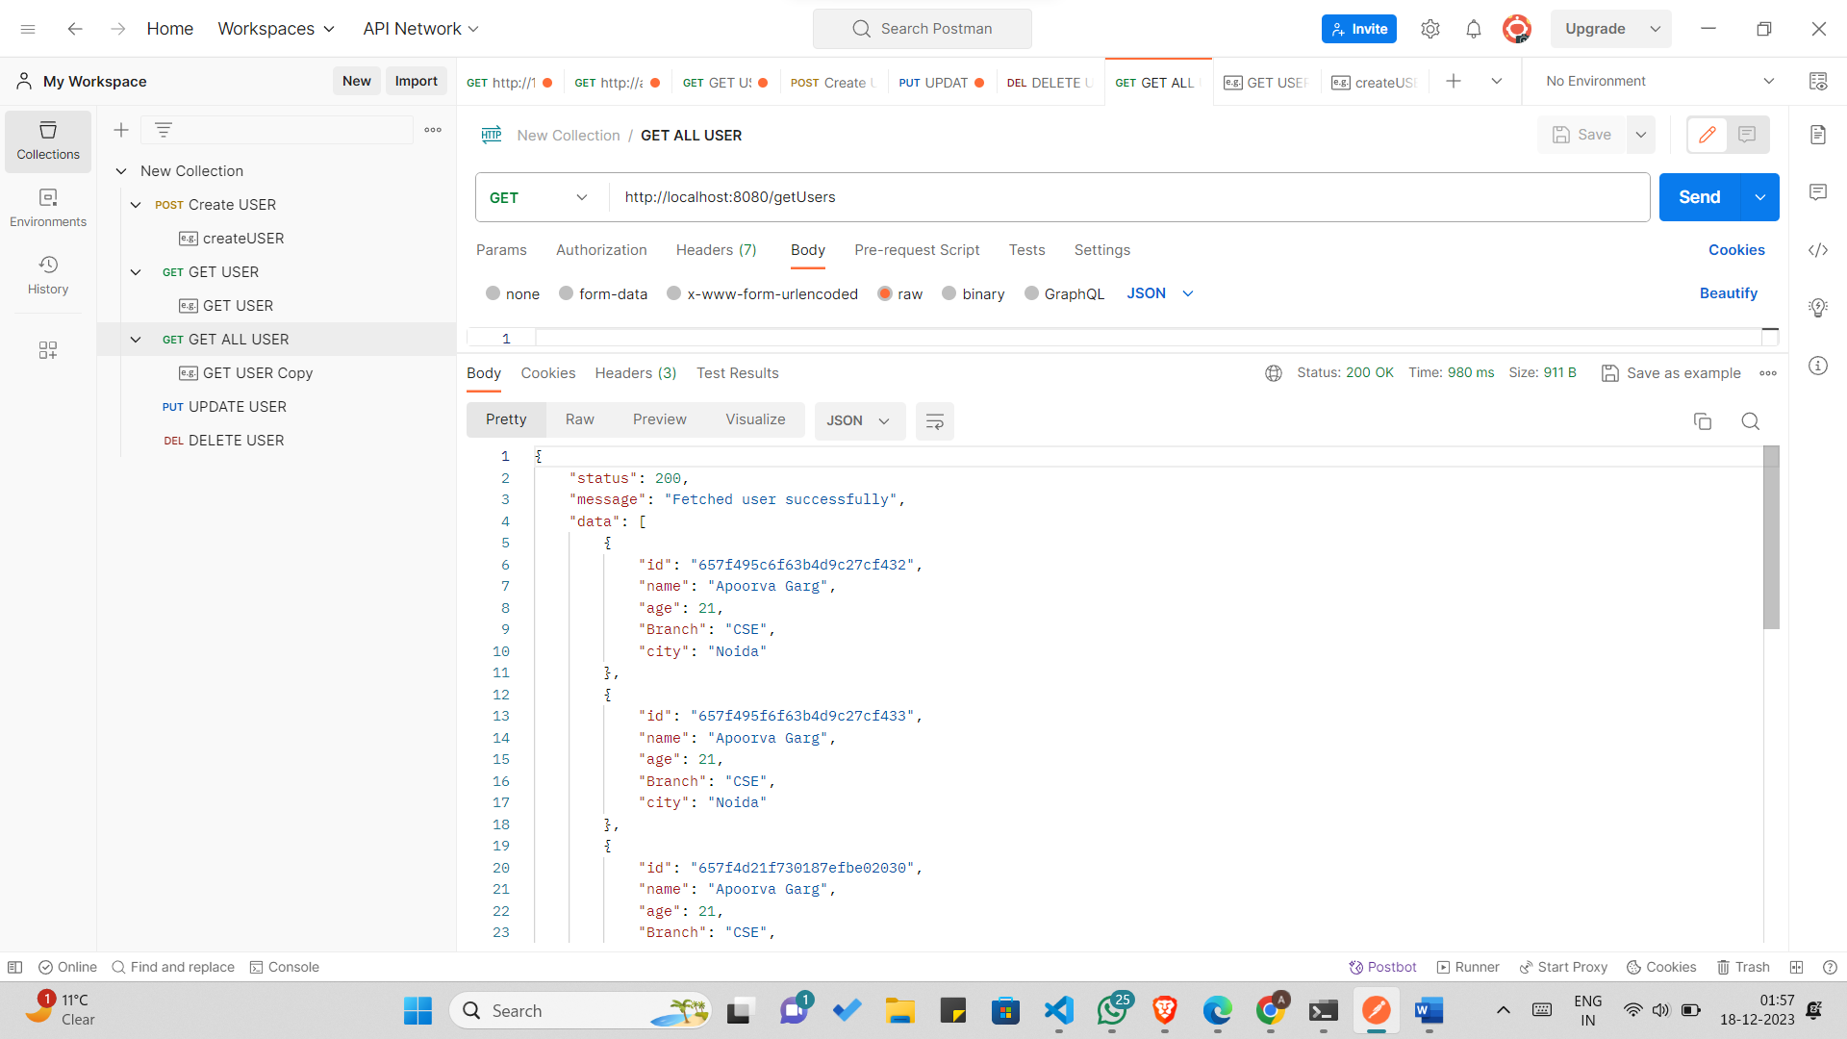

*// UpdatePerson updates a person in the MongoDB collection by ID*

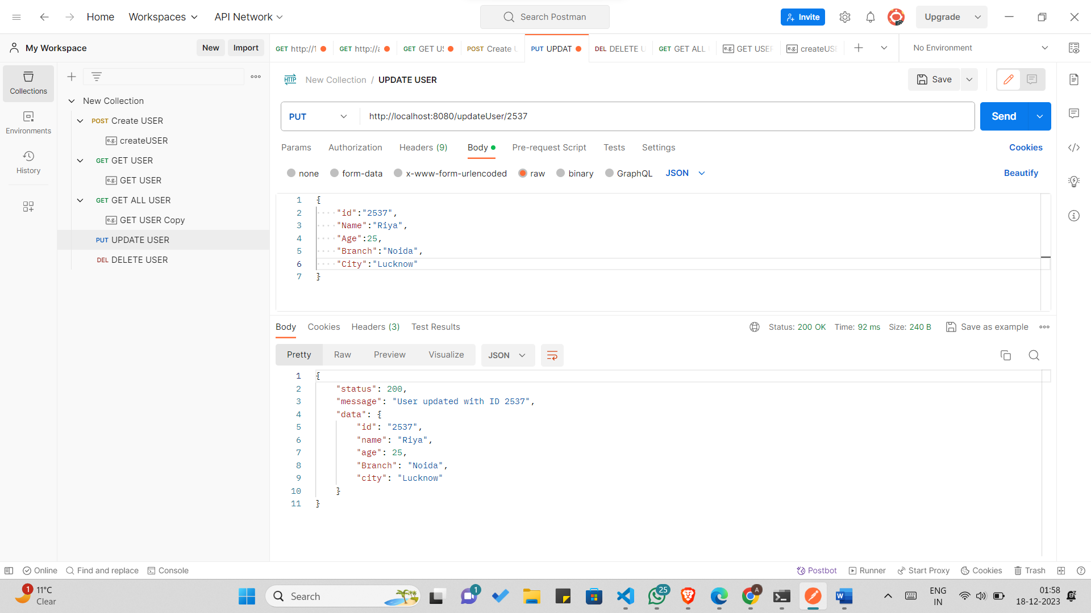

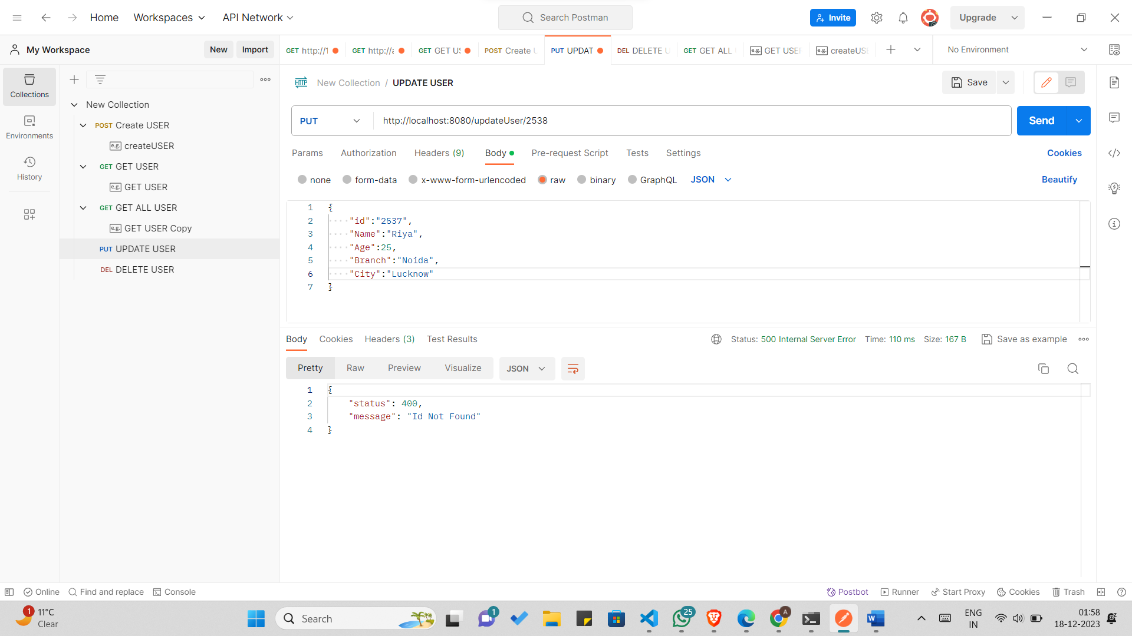

*// DeletePerson deletes a person from the MongoDB collection by ID*

